***Assignment 2.1:***

Q a: Write a Java code with the class name, “acad,” and a method called “main.” Hard code the program with two integers and print the sum of those two integers.  
**import** java.util.*;

**public** **class** acad {

**public** **static** **void** main(String args[])

{

**int** x=936;

**int** y=76;

**int** sum=x+y;

System.***out***.println(sum);

}

}

OUTPUT:  
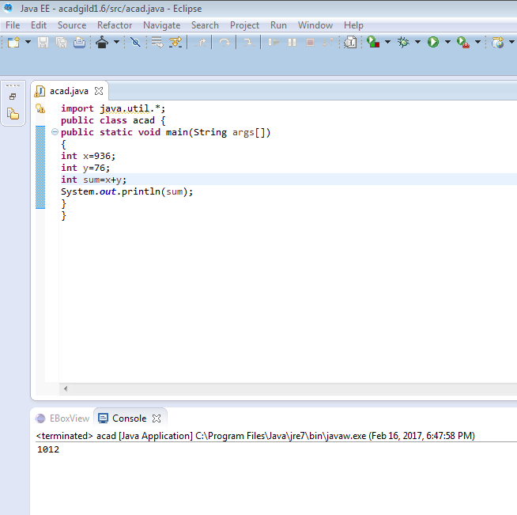  
  
  
Q b: Rewrite the above code, wherein the inputs are provided by the user at runtime and the output is printed.  
**import** java.util.*;

**public** **class** acad {

**public** **static** **void** main(String args[])

{

Scanner s=**new** Scanner(System.***in***);

System.***out***.println("enter the value of x");

**int** a=s.nextInt();

System.***out***.println("enter the value of y");

**int** b=s.nextInt();

**int** sum=a+b;

System.***out***.println(sum);

}

}

OUTPUT:  
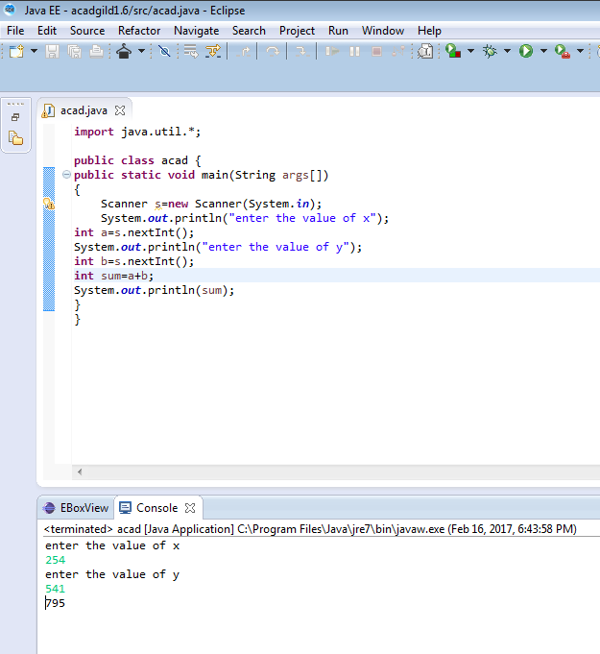

Q c: Write a program with the method name, “sum()” that accepts two parameters from the user and print the sum of those two numbers.   
The output format should be:  
First number is:   
Second number is:   
Sum is:

**import** java.util.*;

**public** **class** acad {

**public** **static** **void** main(String args[])

{Scanner s=**new** Scanner(System.***in***);

**int** a=s.nextInt();

**int** b=s.nextInt();

System.***out***.println("First number is:" +a);

System.***out***.println("Sceond number is:" +b);

System.***out***.println("Sum is:" +*sum*(a,b));

}

**public** **static** **int** sum(**int** a,**int** b){

**int** x=0;

x=a+b;

**return** x;

}}

OUTPUT:  
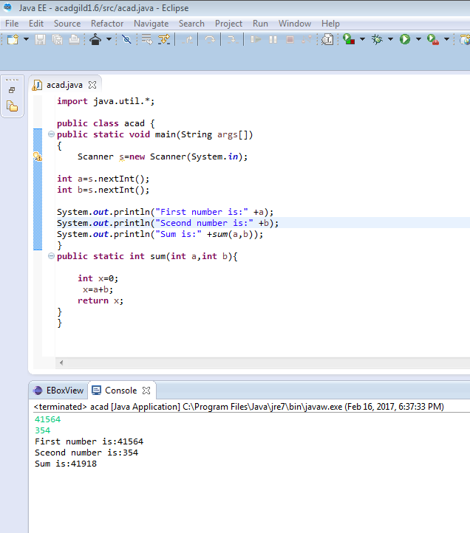

Q d:  
**import** java.util.*;

**public** **class** acad {

**public** **static** **void** main(String args[])

{

Scanner s=**new** Scanner(System.***in***);

System.***out***.println("enter the starting value a");

**int** a =s.nextInt();

System.***out***.println("enter the ending value b");

**int** b =s.nextInt();

System.***out***.println("even and odd present in between are");

**while**(a<b-1)

{

a++;

System.***out***.print(a+" ");

}}}

OUTPUT:  
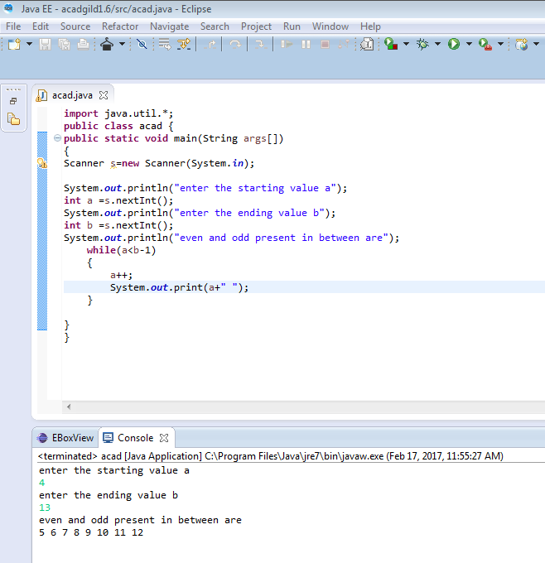

Q e:  
**import** java.util.*;

**public** **class** acad {

**public** **static** **void** main(String args[])

{

Scanner s=**new** Scanner(System.***in***);

System.***out***.println("enter the a value");

**int** a =s.nextInt();

**int** i;

**for**(i=1;i<=10;i++)

{

System.***out***.println(a+"X"+i+"="+(a*i));

} }}  
  
OUTPUT:  
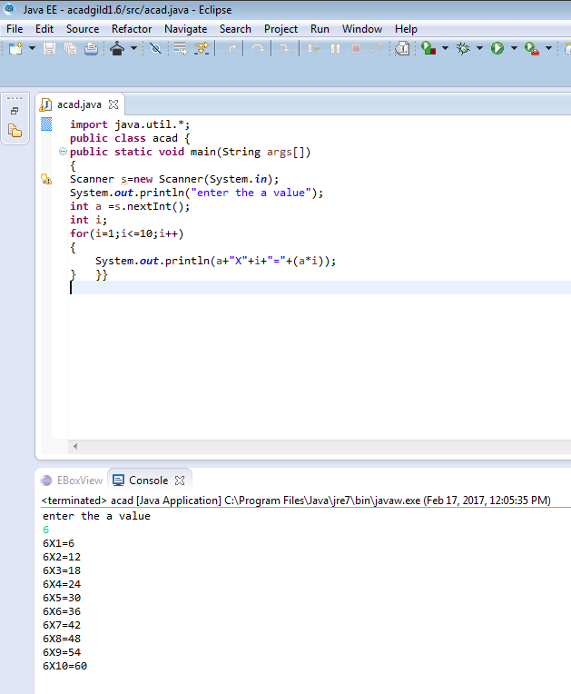  
  
  
Q f:  
**import** java.util.*;

**public** **class** acad {

**static** **int** sum(**int** x,**int** y){

**return** x+y;}

**static** **int** sum(**int** x,**int** y,**int** z){

**return** x+y+z;}

**public** **static** **void** main(String[] args) {

Scanner s=**new** Scanner(System.***in***);

System.***out***.print("enter the first number:- ");

**int** a=s.nextInt();

System.***out***.print("enter the second number:- ");

**int** b=s.nextInt();

System.***out***.print("enter the third number:- ");

**int** c=s.nextInt();

System.***out***.println("Sum is:- "+*sum*(a,b,c));

}}  
OUTPUT:  
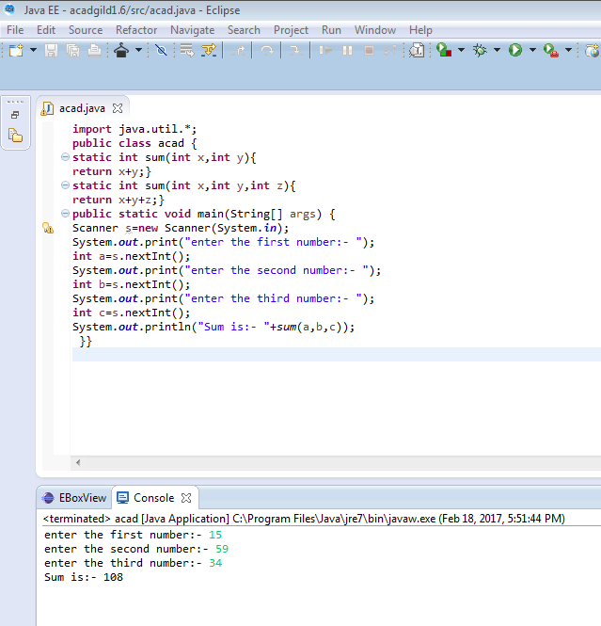

Q g: Yes.  
Overridden method can have same type or sub-type of the original return type which is called  
covariant return. If you change the return type of the overridden method to something else which is not a sub-type of the original type, then you'd get a compile time error.  
In the previous code I used same return type for both methods.   
  
  
  
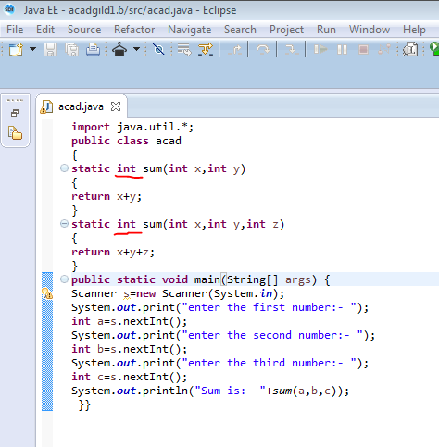  
  
  
  
  
  
Q h:  
**import** java.util.*;

**public** **class** acad {

**public** **static** **void** main(String[] args) {

Scanner s=**new** Scanner(System.***in***);

**int** n,a[],b[];

n=s.nextInt();

a=**new** **int**[n];

b=**new** **int**[n];

**for**(**int** i=0;i<n;i++)

{

a[i]=s.nextInt();

}

Arrays.*sort*(a);

System.***out***.print("Descending order:");

**for**(**int** i=0;i<n;i++)

{

b[i]=a[n-i-1];

}

**for**(**int** i=0;i<n;i++)

System.***out***.print(" " +b[i]);

}}  
  
OUTPUT:  
